Plotting Quadratic Graphs

Find points and plot the graph of:

y = x² + 2x + 1

x | -3 | -2 | -1 | 0 | 1 | 2 | 3 | 4 | 5
x²
+2x
+1
y

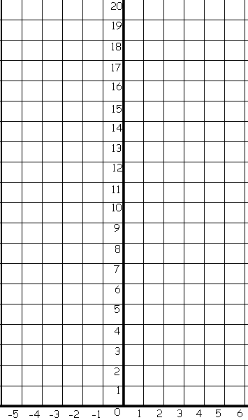

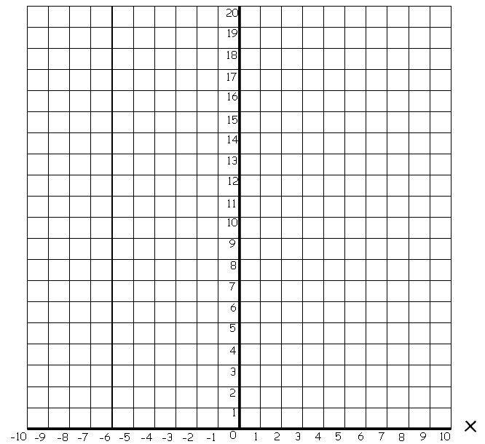
Plotting Quadratic Graphs

Find points and plot the graph of:

y = x² + x + 2

x | -3 | -2 | -1 | 0 | 1 | 2 | 3 | 4 | 5
x²
+x
+2
y

